Quantitative methods to assess Sustainability (Polytechnical Foundation)

Exercise in teaching session: Defining the object of assessment

The object of assessment should be defined according the following parameters:
-What?
-How much?
-For how long /how many times?
-Where?
-How well

As in this example on an outdoor paint (MZ Hauschild, RK Rosenbaum, SI Olsen: Life Cycle Assessment, Theory and Practice DOI 10.1007/978-3-319-56475-3)

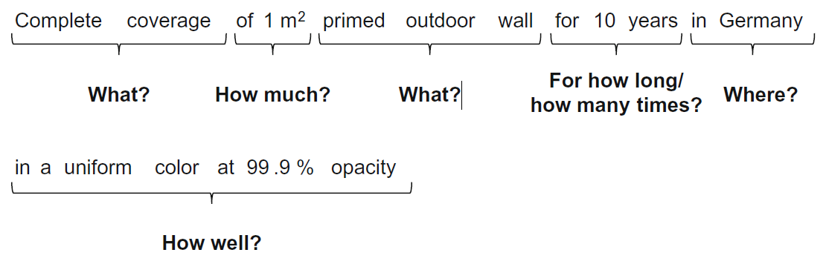
In the video you were asked to consider the functional unit of a water boiler and a lawn mower.
For this exercise please define the functional unit of:
- A car
- A coffee

